Physics Stage 3 STAWA Set 2

- If you want to throw a ball as far as is theoretically possible the best angle to throw it is 45.0°above the horizontal. Explain why this gives the maximum range.

To achieve the maximum range ie the longest throw the time of flight (as well as horizontal velocity) must be a maximum. The higher the projectile goes the longer the time of flight so it must be thrown so that there is some vertical velocity. The reality is that there must be a compromise between time of flight and horizontal velocity (best theoretical angle is 45°), as well as the angle at which the maximum force is achieved by the thrower. The flight characteristics of the projectiles also have an influence on the range.

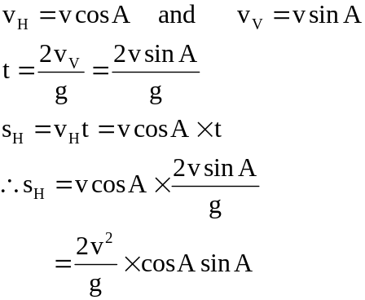  For a given launch velocity sH the range is a maximum when cosAsinA is a maximum. As you can see from the graph this occurs when A is 45° | 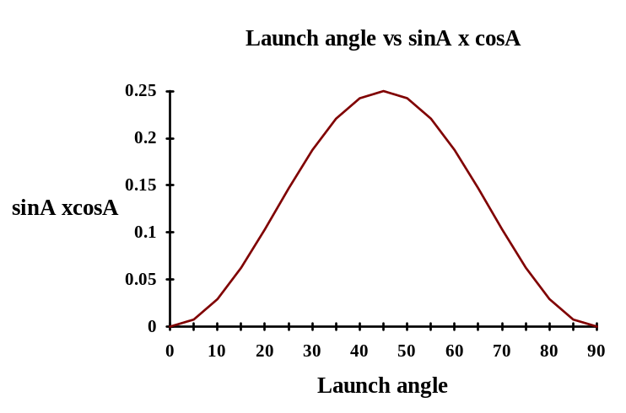

- A fielder on the boundary of a cricket oval returns the ball to the wicketkeeper. Why does the force of gravity not affect the horizontal velocity of the ball?

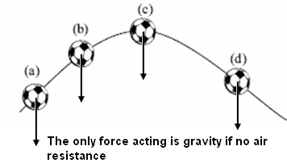
Force due to gravity is directed in a vertical direction. It has no component in the horizontal direction.

- The figure below shows the flight path of a soccer ball. It is shown at four positions:

  - just after it is kicked,
  - as it rises,
  - when it is at the top of its path
  - and as it falls

Show with an arrow the resultant force acting on the ball at each position. If there is no resultant force, write ‘no force’. You may ignore the effects of air resistance.

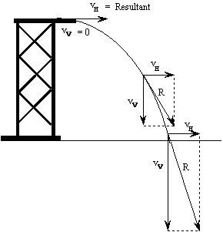
- A high-board diver jumps horizontally away from the diving tower. Draw a diagram to show the path she will take as she dives into the pool. On the diagram draw arrows to show her vertical, horizontal and resultant velocities at the top, middle and near the bottom of her dive.

- In a shooting competition the target is 1.00 x 10³ m from the competitors. The shooters set the sights on their rifles so they aim a certain distance above the target. Explain why the bullet still manages to hit the target.

As the bullet travels towards the target it is subjected to an acceleration downwards (due to gravity). It will therefore begin to fall. The sights are adjusted so that the rifle is aimed a distance above the target equal to the distance the bullet will fall as it travels from the gun to the target.
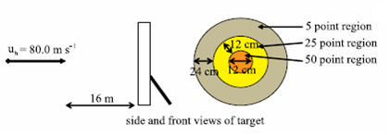
- An inexperienced archer in a competition aims his bow and arrow at the centre of a target. He stands 16.0 m from the target. The bow is capable of firing the arrow at 80.0 m s⁻¹. Assuming that there is no air resistance, and the archer always fires the arrow at its maximum speed and it leaves his bow horizontally, what score will the archer achieve?

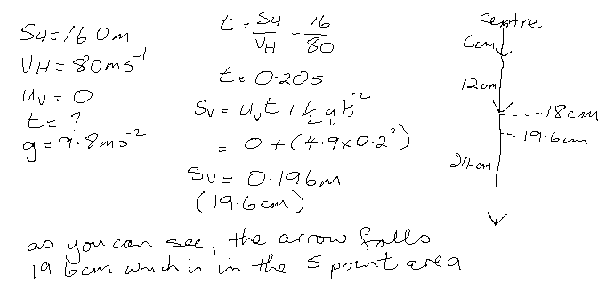

- A long jumper jumps at an angle of 16.5°. If he launches with a velocity of 7.90 m s⁻¹, how far should he jump?
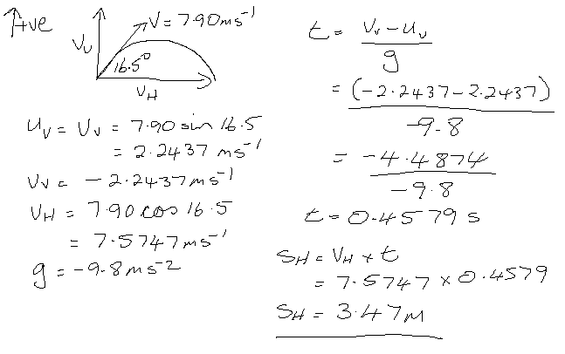

- At a fun fair your friend and you decide to try your hand at a ‘knock-em-down’ game. The target is a stack of empty cans about four metres away at head height. You have four foam rubber balls to use. Your friend tells you to throw the balls as fast as possible. The operator advises you that throwing them more slowly may be better. Explain how each method could successfully knock down the stack of cans.

Throwing the balls fast requires that they be aimed only slightly above the cans.
Throwing the balls slowly requires that the balls be aimed at some significant distance above the cans.
In both cases if the balls are aimed a distance above the cans equal to the distance the balls will fall in the time taken to reach the cans, they will hit the cans.

- A gymnast dismounts from a beam by leaping into the air doing a somersault and then landing on the floor in a standing position. If she takes off from the beam in a standing position with a velocity that has a vertical component of 4.00 m s-1 upwards, how long is it before she lands on the floor? The beam is 1.1 m above the floor.

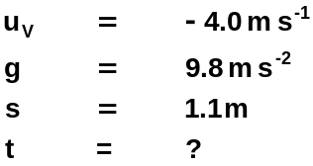 | 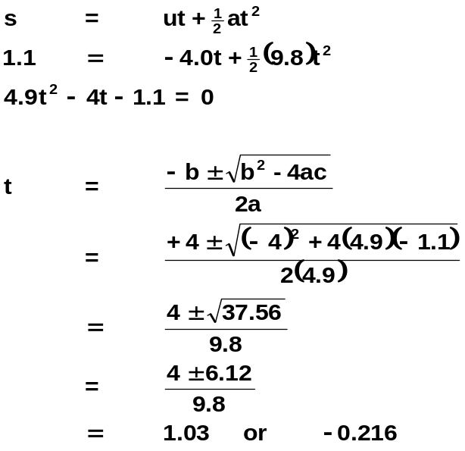
Time before she lands is 1.03 s

- A baseball player pitches the ball at an angle of 10° above the horizontal with a speed of 22.5 ms⁻¹ towards the batter who is 19.4 m away. If the pitcher throws the ball from a height of 1.50 m from the ground, at what height does the batter hit the ball?

v = 22.5 m s-1  s = 19.4 m  g = 9.8 m s-2  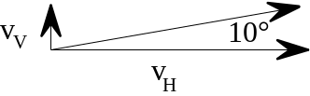  vV = 22.5 sin 10° = 3.90 m s-1  vH = 22.5 cos 10° = 22.2 m s-1 | 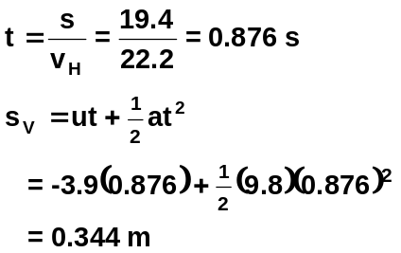  The ball arrives at the batter 0.344 m below the point from which it was pitched.  That is 1.50-0.344 = 1.16 m above the ground.

- Brett kicks a football with an initial velocity of 18.0 m s⁻¹ at 35° to the horizontal.
  - How much time does Peter have to get to a position where he can catch the ball at the same height off the ground as Brett kicks it?
  - How far does Peter have to be from Brett to catch the ball in this way?

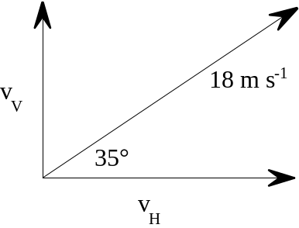  uV = -10.32 m s-1  vv = 10.32 m s-1  g = 9.8 m s-2  t = ? | vV = 18 sin 35° = 10.32 m s-1  vH = 18 cos 35° = 14.74 m s-1  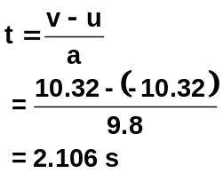  Time to make position = 2.1 s
b
Range = sH = vHt = 14.74 × 2.106
= 31.10 m Distance away is 31 m.

- An athlete can throw a javelin with a maximum velocity of 28 m s⁻¹. If she uses angles of projection between 25° and 40° above horizontal, what is the longest throw she can achieve?

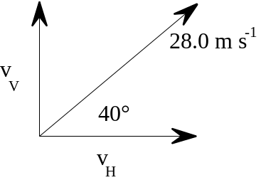 | The longest throw she can achieve requires a launch angle of 40°  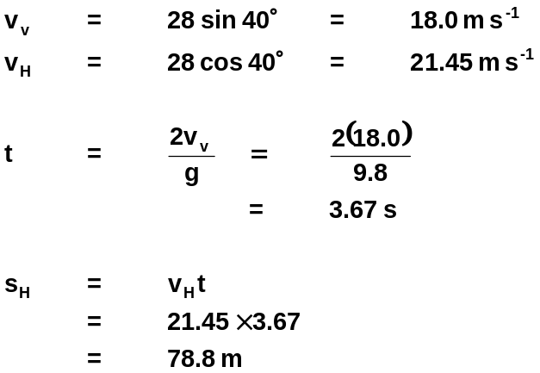
The longest throw she can achieve is 78.8 m (Women's world record = 80.00 m)

- A springboard diver leaves the board 3.00 m above the water with a velocity of 2.30 m s⁻¹ at an angle of 110° to the board. At what horizontal distance from the end of the board will the diver enter the water?

s = 3.0 m  u = -vV = -2.16 m s-1  a = 9.8 m s-2  t = ?  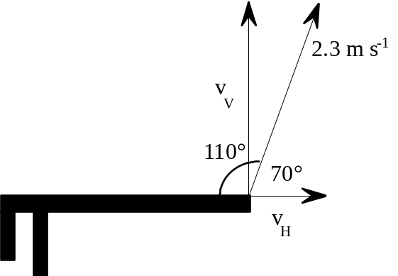 | 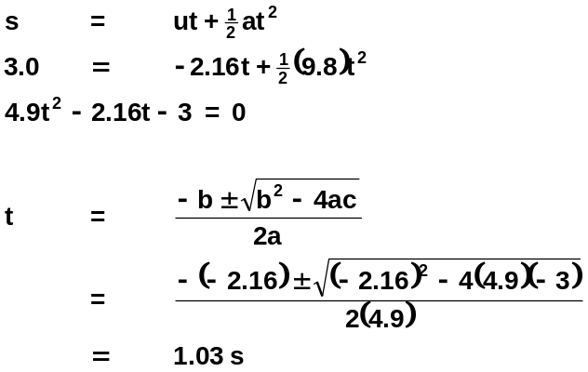  SH = vH × t  = 0.79 × 1.03  = 0.82 m
The diver will hit the water 0.82 m from end of board

- Helicopters are often used to drop water onto small bush fires. A helicopter approaching a bush fire horizontally at a speed of 21.0 m s⁻¹ must release the water no closer than 160 m from the fire and then turn quickly away to avoid flying over the fire. What is the minimum height that this helicopter can fly to ensure that the water reaches the fire?

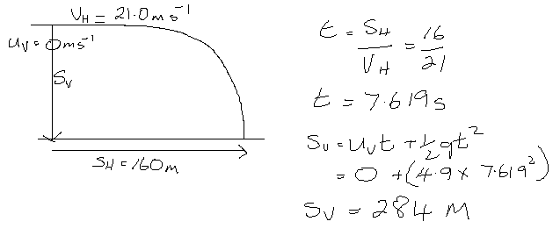

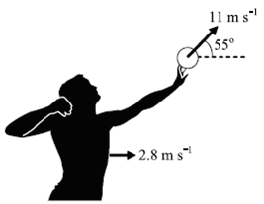
- The shot-putter shown in the diagram throws his shot forward with a velocity of 11 m s⁻¹ with respect to her hand, in a direction 55° above the horizontal. At the same time, the shot-putter’s body is moving forwards horizontally, with a velocity of 2.8 m s⁻¹. At the moment of release, the shot is 2.4 m above the ground.
  - Calculate the vertical and horizontal velocity of the shot putt at the moment it is released.
  - Calculate the shot putt’s maximum height above the ground.
  - Calculate the throw (horizontal range) the shot-putter achieves.

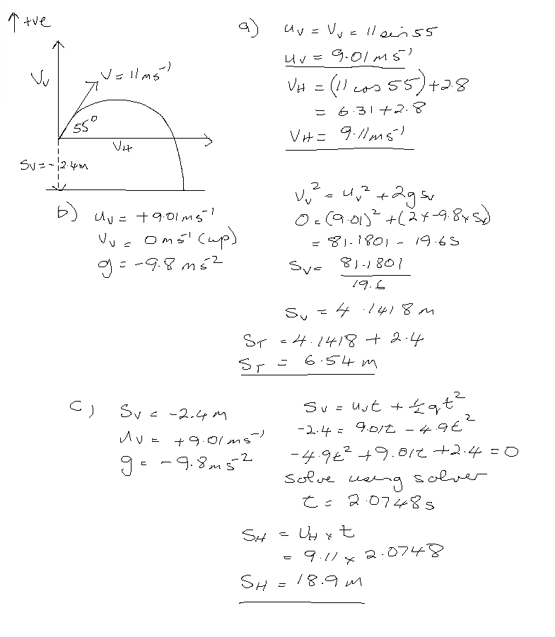

- A stunt woman is attempting to jump across a pair of ramps that are 38.0 m apart in her car. To successfully complete the jump she must drive her car at a minimum constant speed up the ramp.
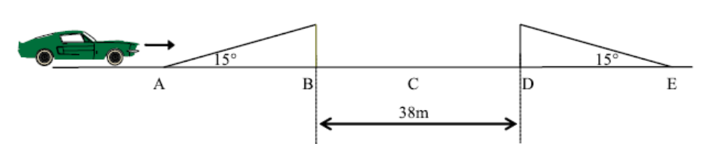
  - If she leaves the ramp with an initial speed of 108 km h⁻¹, calculate (in m s⁻¹) the vertical and horizontal components of her velocity.
  - Will there be a point during the flight of the car where the stunt woman and her car experience zero acceleration? If so where?
  - What will be the velocity of the car at its highest point? You must justify your answer.
  - At what point A, B, C, D, or E in her journey will she have the greatest speed? Why?
  - At what minimum speed must she leave the ramp so as to make it to the other side?

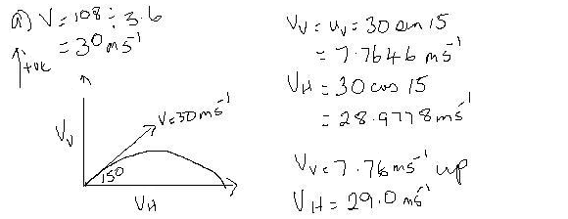
- At all points the car experiences acceleration due to gravity downwards so the answer is no.

- As the horizontal component of the initial velocity is 29.0 ms⁻¹ to the right, then this is the greatest velocity at its highest point as the vertical component of velocity is zero.

- The greatest speed will be at point A and E assuming constant speed. Once she starts to rise up the platform, she is losing kinetic energy to gain potential energy so her speed would be reduced. Once she lands on the other side, she will lose potential energy to gain kinetic energy and assuming no loss of energy to friction and air resistance, her velocity should then be the same as at E.

s_{v} = 0 ms⁻¹ (starts and finish at same place)  u_{v} = V sin 15  u_{H} = V cos 15  s_{H} = 38.0 m | Horizontal: Vertical  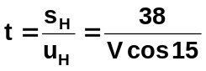 (1) s_{v} = u_{v}t + ½ gt²  0 = (V sin 15)t – 4.9t² (2)  substitute (1) into (2)  0 = V sin 15 x 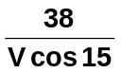 - 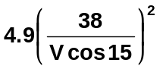  0 = 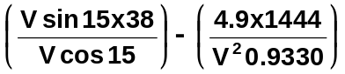  0 = 10.182 - 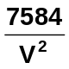  -10.182 = -  V = 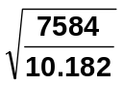  V = 27.3 ms⁻¹
- A cricket batsman is hitting the bowlers all over the ground. One shot that he makes just clears the fence on one part of the ground.

  - Sketch, using a solid line, the path the ball follows if it just clears the fence. Ignore air resistance.
  - Sketch, using a dotted line, the path the ball follows if it just clears the fence, this time taking air resistance into account. Show the forces acting on the ball at its highest point.
  - Another shot he hits goes straight back over the bowler’s head. The fence is 64.0 m away and 1.40 m high. If he hits the ball with a velocity of 28.0 m s⁻¹ at an angle of 35° to the ground, will he clear the fence? Assume that he strikes the ball at ground level, and ignore air resistance.

c.
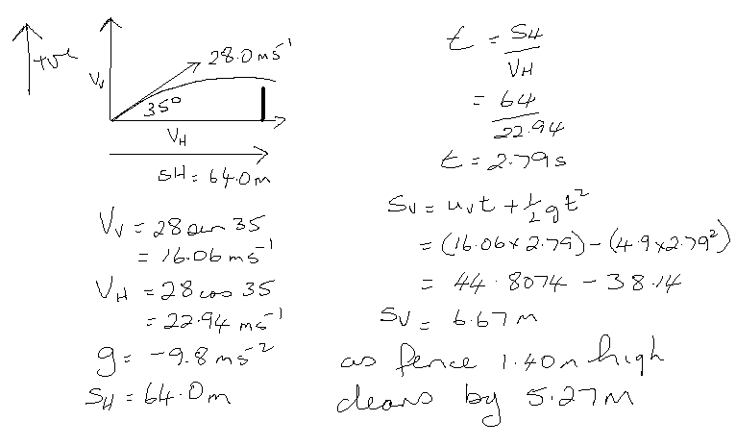

- An archer fires an arrow horizontally towards a target with a velocity of 83.0 m s⁻¹. He fires the arrow from a position 1.35 m above the ground and it hits the bottom of the target, that is 0.450 m above the ground. Determine the distance between the archer and the target.

vH = 83.0 m s-1  sH = ?  sFall = 1.35 - 0.45  = 0.90 m | 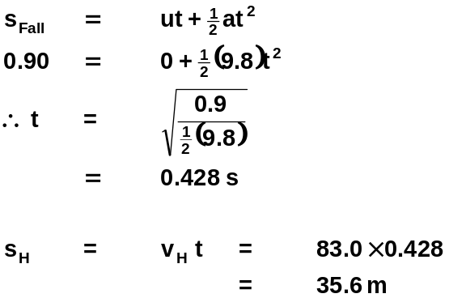
Target is 35.6 m from archer

- A basketball player shoots successfully at goal from a horizontal distance of 5.3 m to the centre of the goal-ring. She releases the ball at an angle of 48° to the horizontal and 1.2 m below the height of the ring. Calculate the ball’s speed as it left her hands.

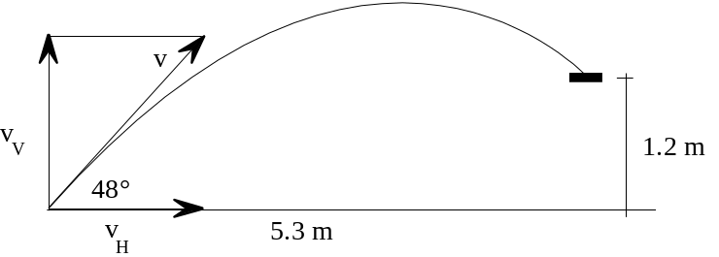

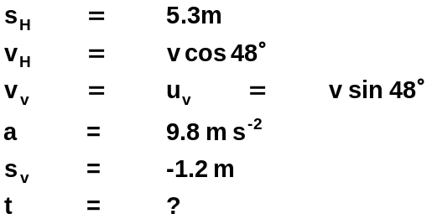 | 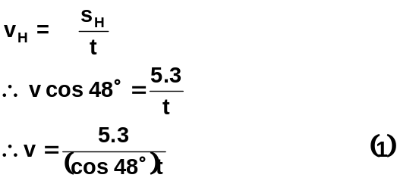  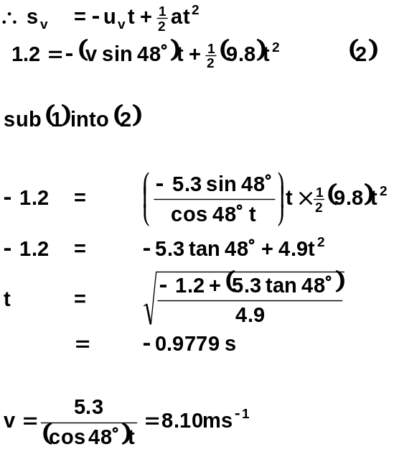

The launch velocity was 8.10 m s-1

- Marc returns a volleyball from near the floor as he stands on the middle of the baseline. He hits the ball with a velocity of 13 m s⁻¹ at an angle of 48° above the horizontal directly towards his opponents’ base line. The court is 18 m long and the ceiling in the gymnasium is 6.0 m above the floor.
  - Show that the ball does not hit the ceiling.
  - Show that the ball lands in the court if his opponents fail to touch it before it lands.

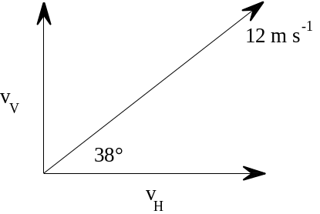 | 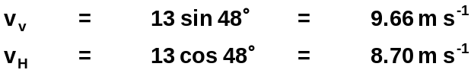
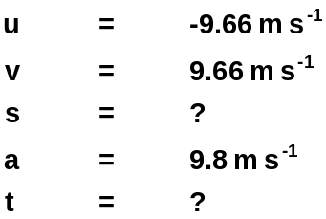 | 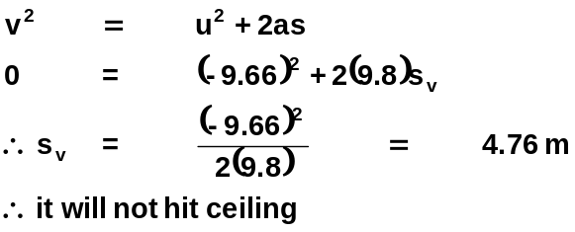
b  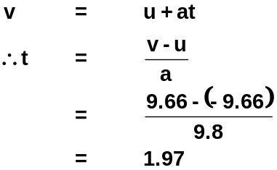 | 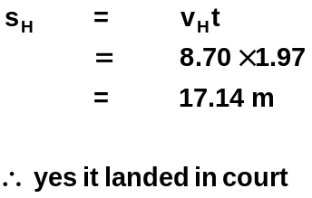

- Very fast sprinters are often also very good at long jump. Explain why this might be so.

The range can be increased if the horizontal velocity is increased at take off. The fast sprinter therefore has a large horizontal velocity and hence potentially achieves a greater range.

